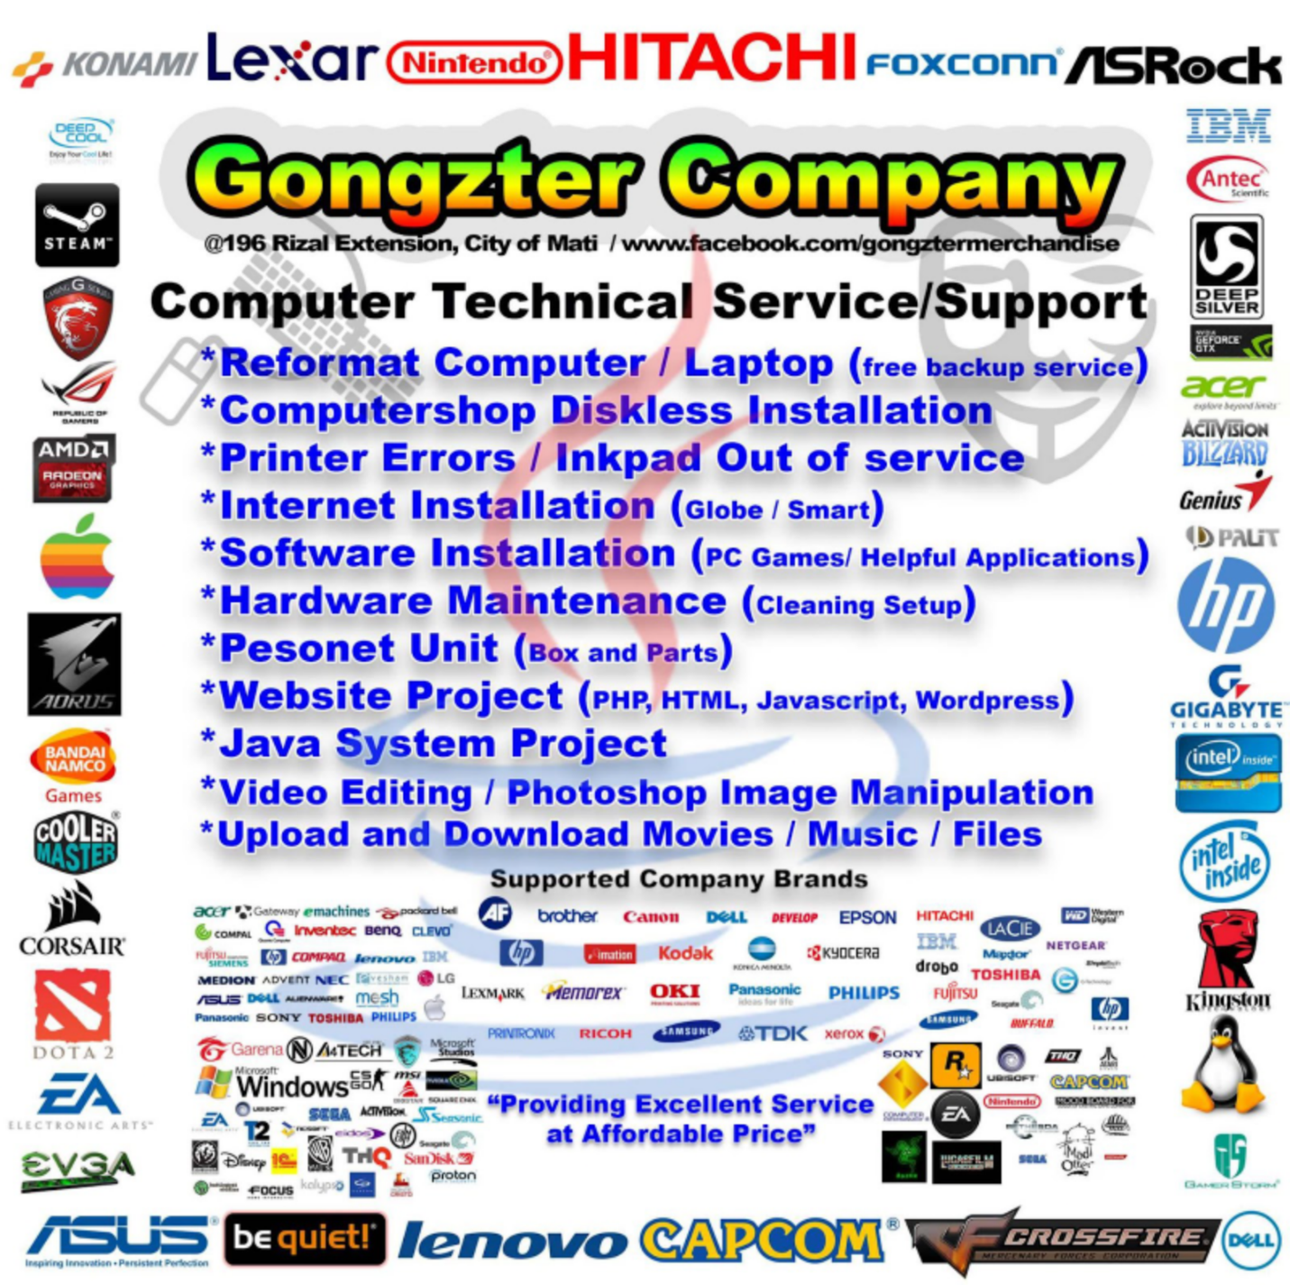

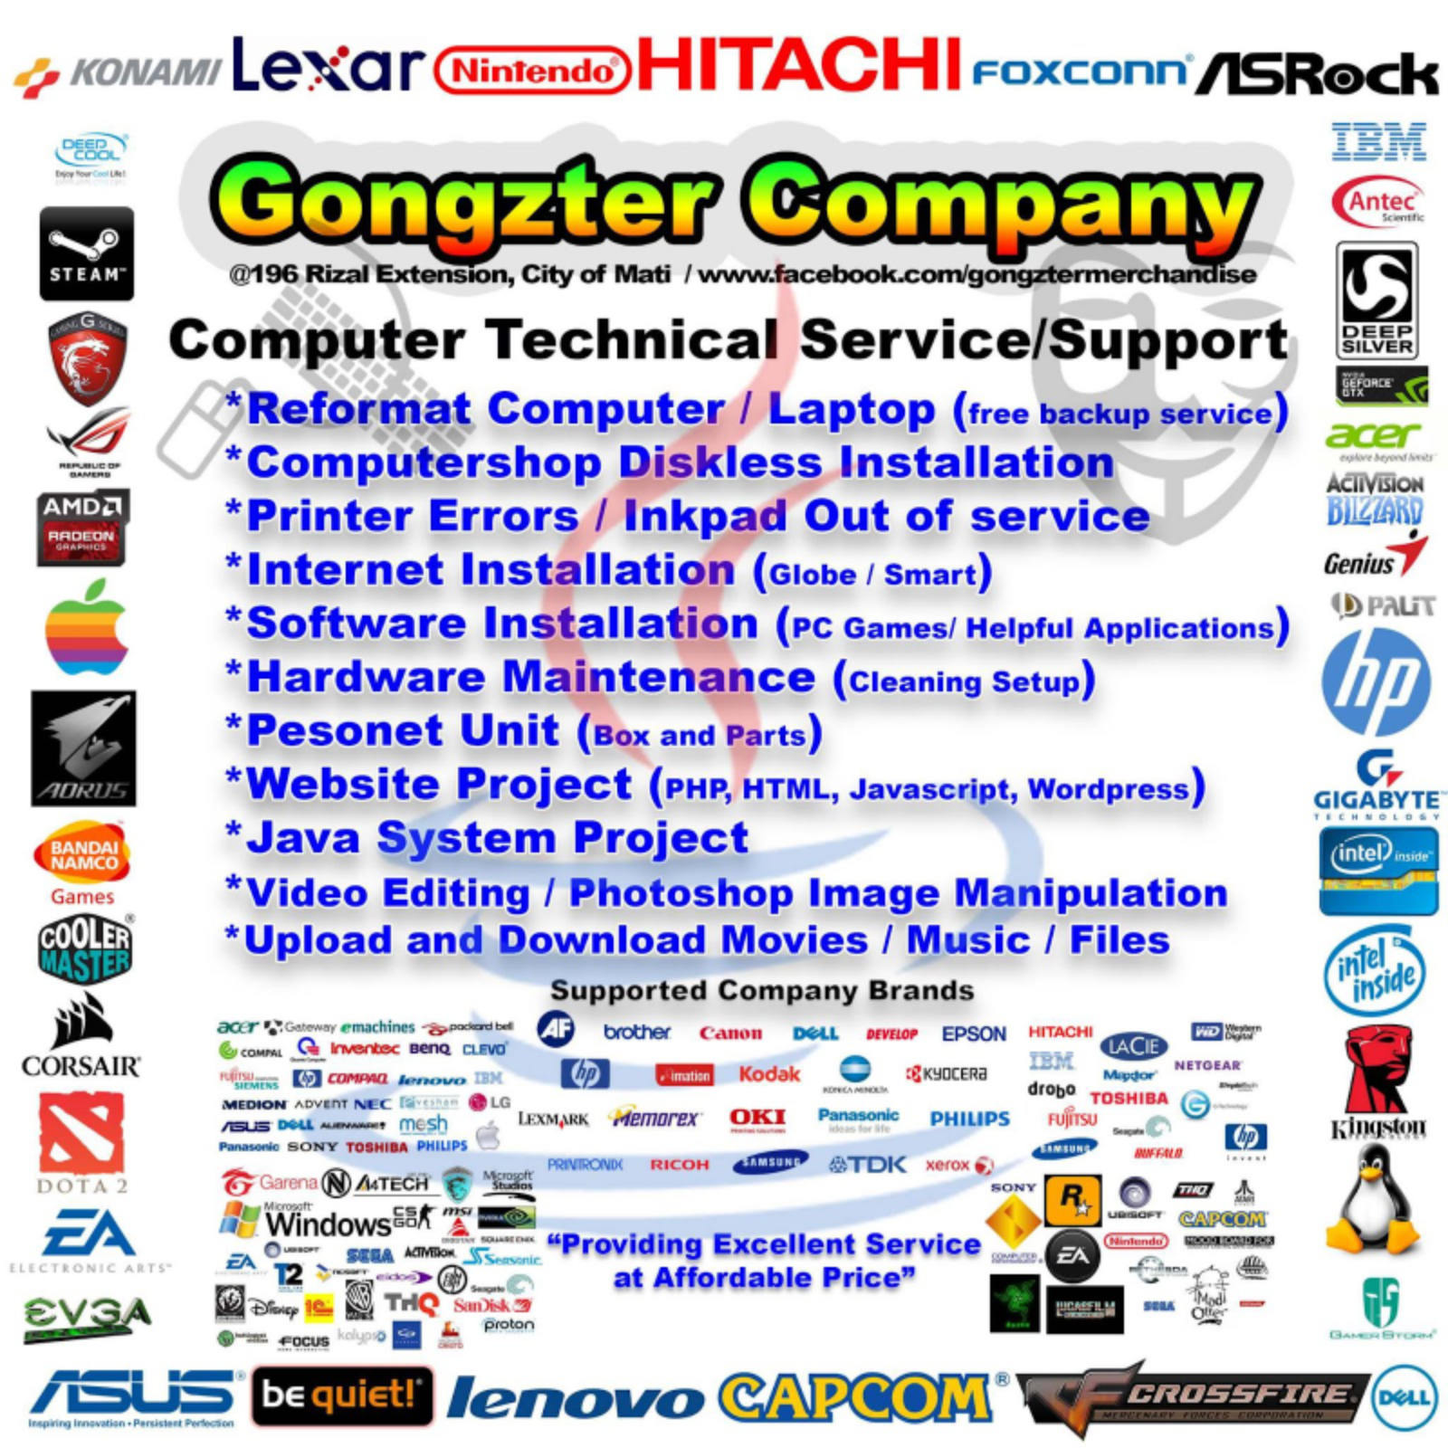

**PROJECT BRIEF**

**Project Title:** GONGZTER COMPANY WEBSITE

1. **CLIENT INFORMATION**

*COMPUTER TECHNOLOGY SERVICE, SUPPORT & STORE*

1. **CONTACT**

|  |  |
| --- | --- |
| Name: | ARNEL VINCENT C. ALLERA |
| Email address: | [gongztercompany@gmail.com](mailto:gongztercompany@gmail.com) |
| Phone number: | 09514108705 |

1. **PROJECT DETAILS**

|  |  |
| --- | --- |
| Target audience: | CUSTOMERS |
| Specific Project Goals/Objectives: | POST PRODUCTS, BUY AND SELL, CREATE LOGIN SYSTEM FOR CUSTOMERS. |
| Project Cost | ₱519,300 |

Note:

* Customize the letterhead with the name of your company (actual or dummy company)